

**Lab Manual- Administrating Azure Virtual Machine – Windows Admin Center**

**Prepared for**:

**Date:** 18th March 2022

**Prepared by:**

Document Name: Lab Manual **Document Number** AZLabn991

**Contributor:**

Contents

1. Objective 3

2. Lab 1: Installing the Windows Admin Center extension package in the Azure VM through the Azure portal 3

3. Lab 2: Explore Management Features of Admin Center 6

1. Overview 7

2. Devices 7

3. Events 8

4. File & File sharing 9

5. Firewall 10

6. Installed apps 11

7. Local Users and Groups 11

8. Performance Monitor 11

9. Powershell 12

10. Processes 12

11. Registry 13

12. Remote Desktop 13

13. Roles and features 13

14. Storage 14

15. Updates 14

16. Settings 15

15

4. Conclusion: 15

# Objective

Windows Admin Center in the Azure portal provides the essential set of management tools for managing Windows Server in a single Azure VM:

* Certificates
* Devices
* Events
* Files and file sharing
* Firewall
* Installed apps
* Local users and groups
* Performance Monitor
* PowerShell
* Processes
* Registry
* Remote Desktop
* Roles and features
* Scheduled tasks
* Services
* Storage
* Updates

# Lab 1: Installing the Windows Admin Center extension package in the Azure VM through the Azure portal

1. In in the Virtual Machine setting , click Windows Admin Centre

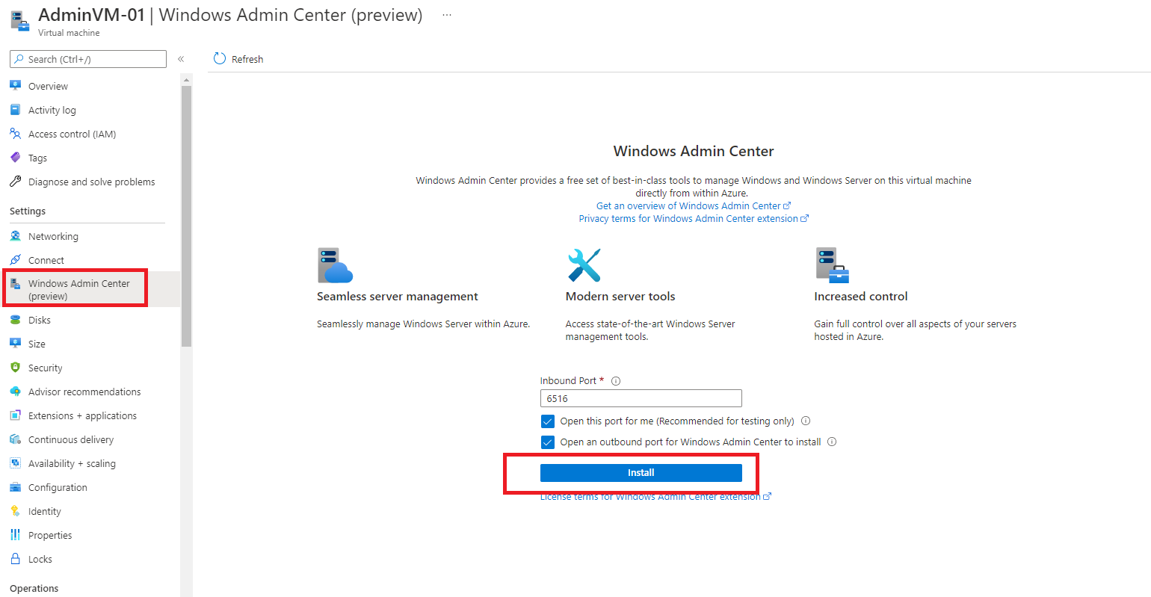

1. **Select Open this port for me and click install**

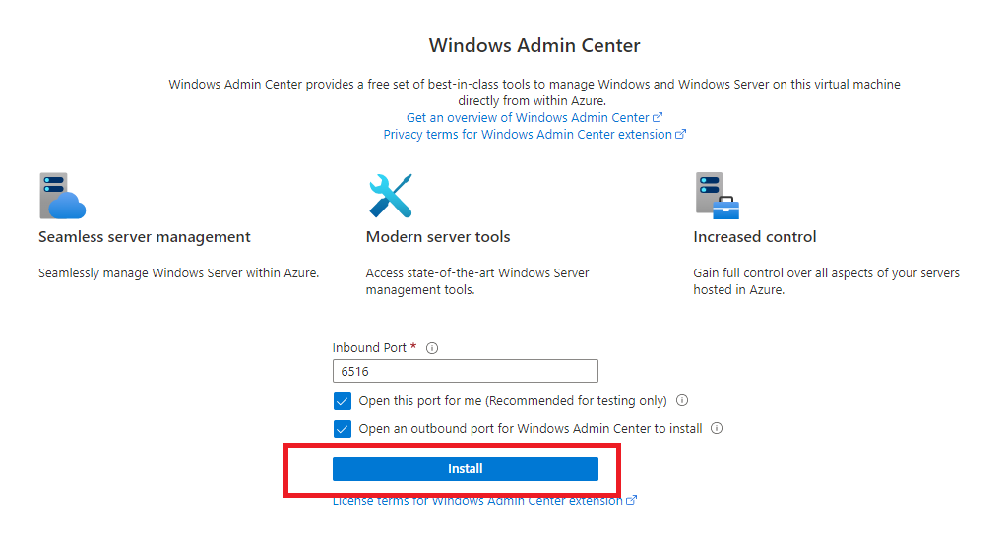

1. **It take few minutes and once done Click Connect**

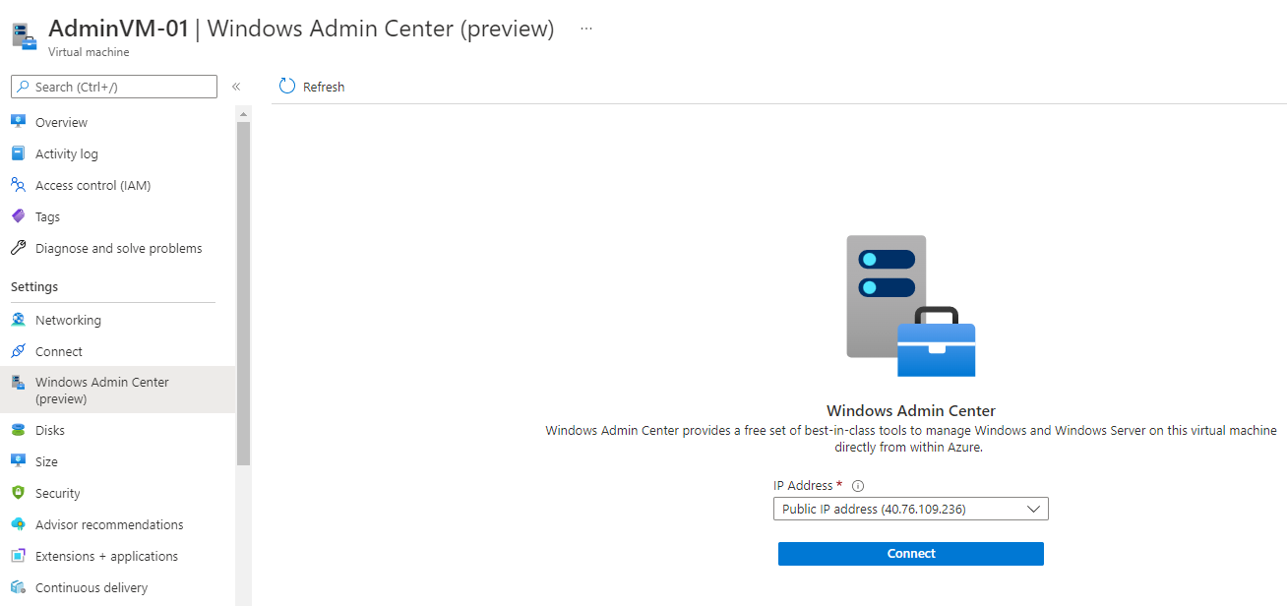

1. On the next screen, the wizard asks you the admin user credentials of the VM. The below screenshot shows this sign-in page. **Type VM username and Password and click Sign-in**

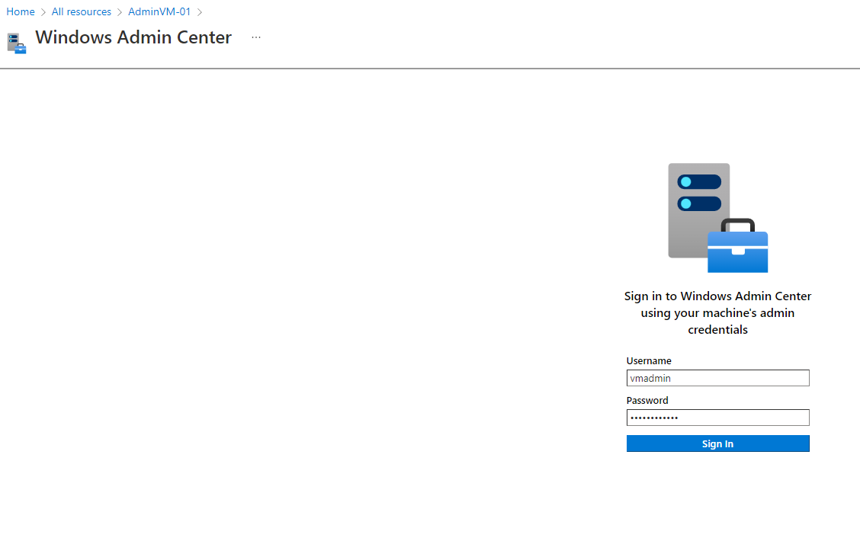

1. **It take less than minute to initialize**

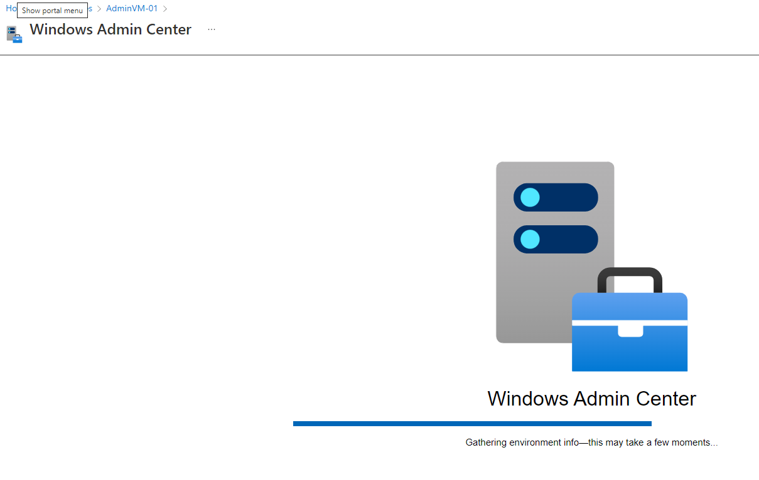

1. Now, your VM is connected to the Windows Admin Center, and you can view various management tools on the left side. On clicking each tool, you will get the relevant details on the right side. Some of the screenshots shown below are given for example.

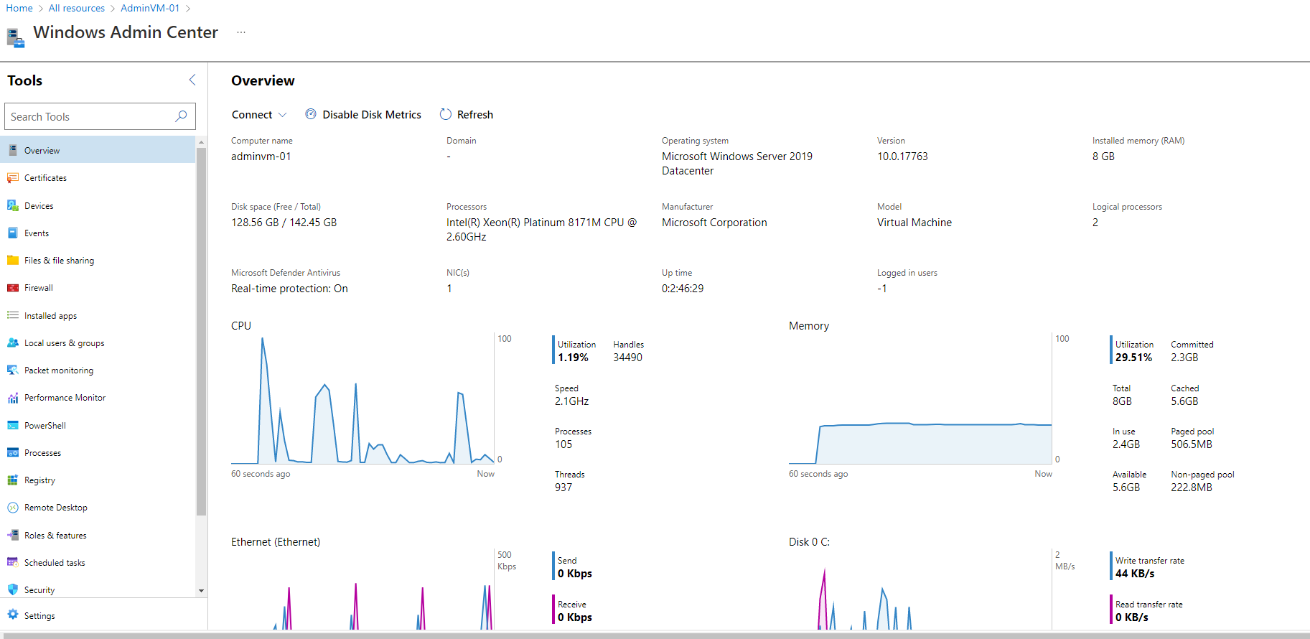

# Lab 2: Explore Management Features of Admin Center

## Overview

This page shows the complete details of the OS such as OS version, Installed RAM, Available Disk space, Processor details, CPU Utilization, Memory usage, and Ethernet activity. The below screenshot shows these parameters

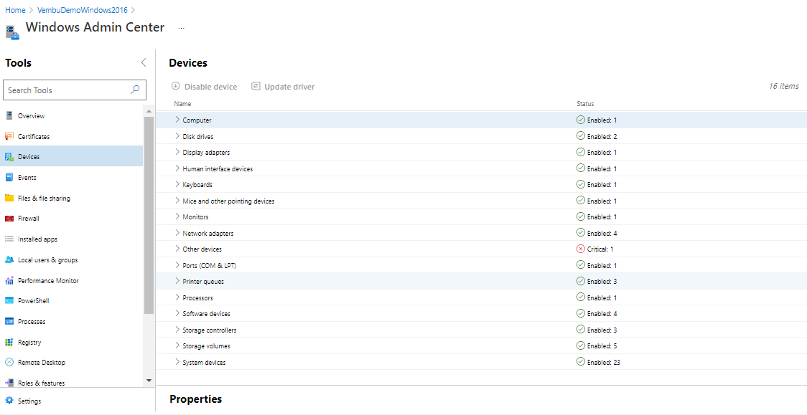

## Devices

Shows details of all the devices available in the VM. You can disable or update the driver of these devices from the Windows Admin center portal itself. You can expand each component and get the detailed properties of each device.



## Events

You can view the events generated by the Windows log & the Application and services log. You can choose each event and get a detailed description of the event. The below screenshot provides a sample event with a description.

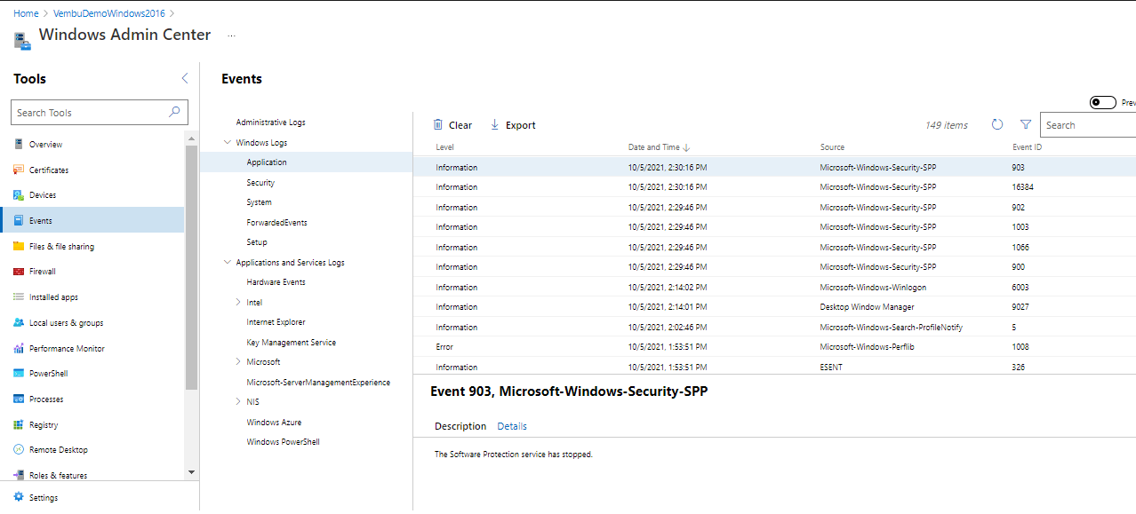

## File & File sharing

Users can view directories and files under each drive. Users can do all the file activities similar to file explorer in windows os. They can also do all the file-sharing activities under the File sharing tab. They can create a new share, delete a share and edit the share properties.

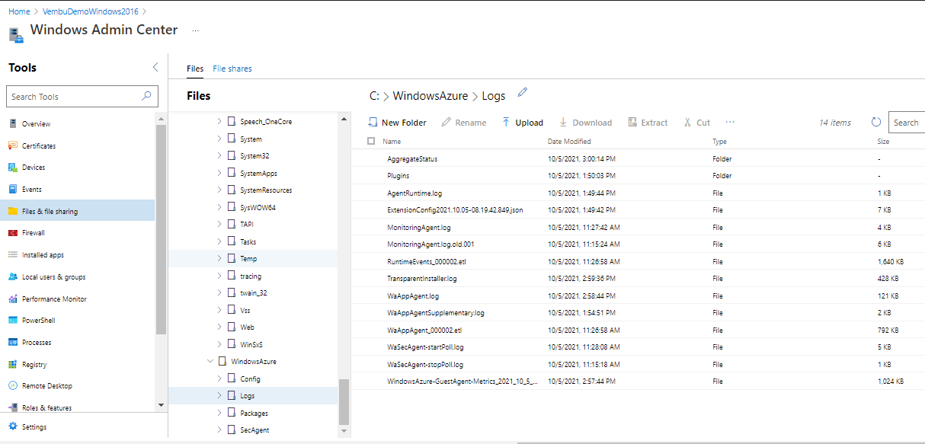

## Firewall

Users can set Incoming & Outgoing firewall rules for the Windows OS from this section. Users can enable, disable or modify the firewall rule from here by selecting each of the Incoming and Outgoing rules.

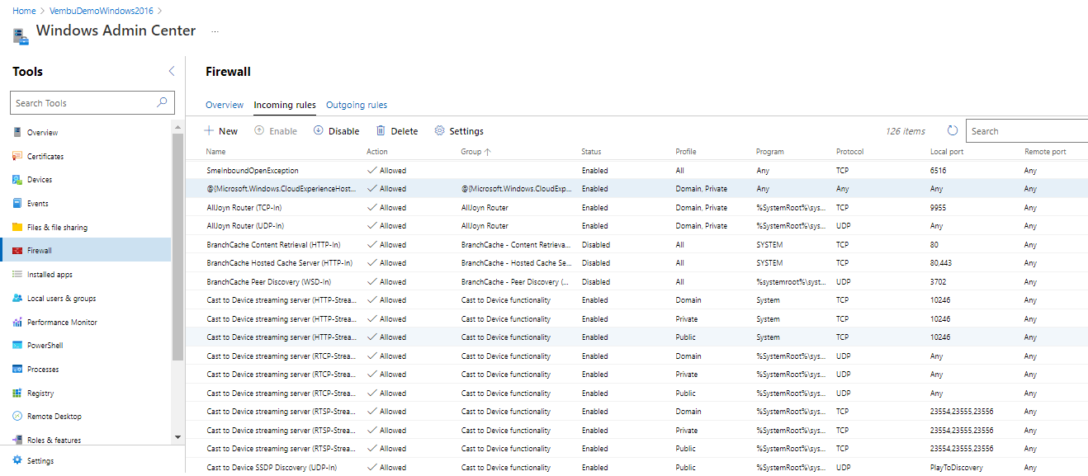

## Installed apps

This tab shows complete details of the installed application on the Windows OS. You can uninstall or remove the application from the OS here itself.

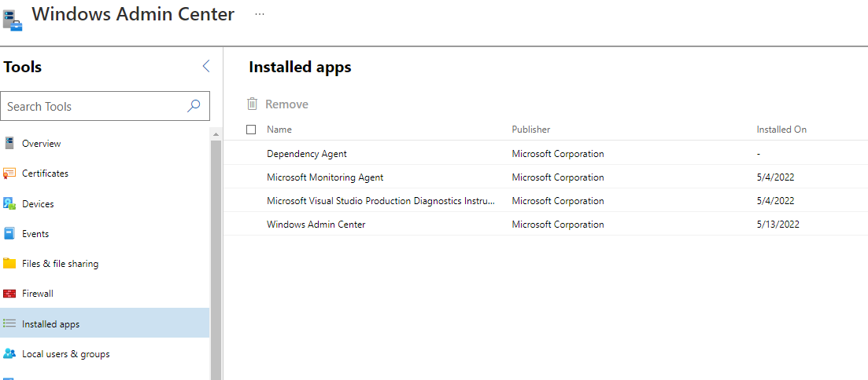

## Local Users and Groups

This will list all the available users (built-in and created users ) of the OS and the built-in groups. Here you can create a new user or group. Can edit or remove the user or group and can change the password for a particular user.

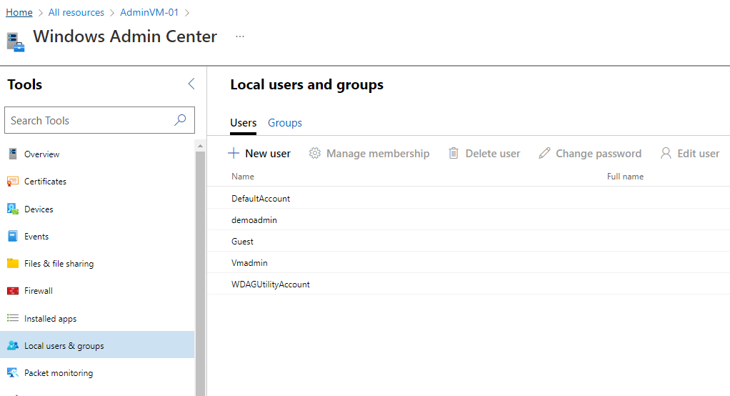

## Performance Monitor

Users can view and compare performance counters for the operating system, apps, or devices in real-time.

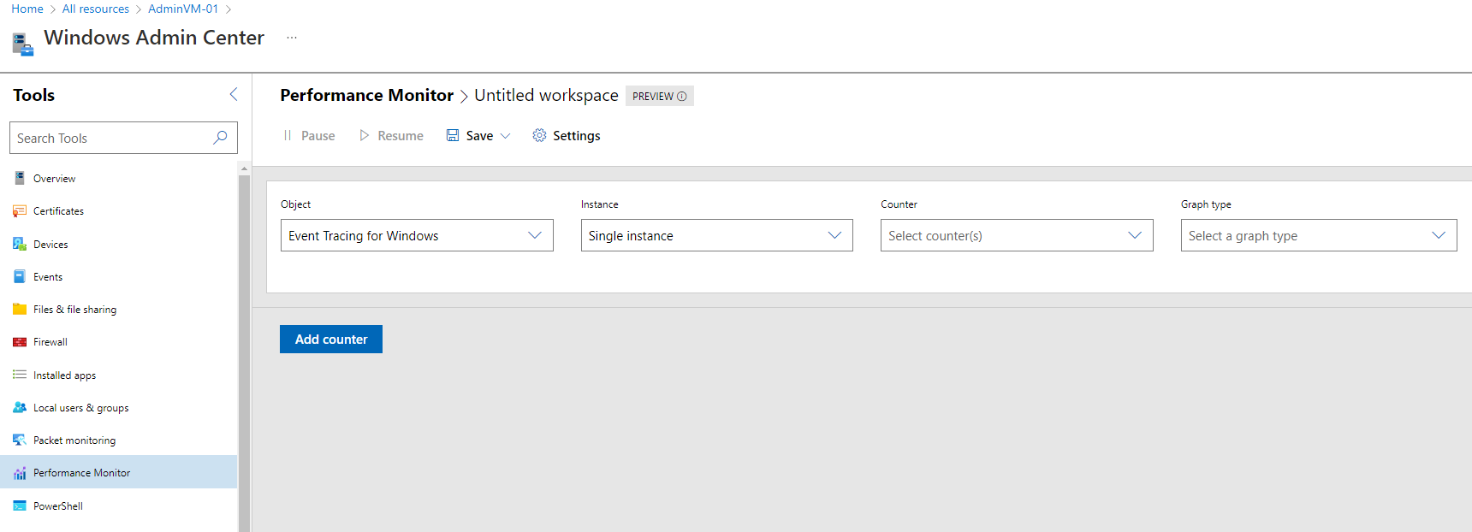

## Powershell

Using this, you can connect the Powershell window of the Windows OS directly, and can execute any PowerShell cmdlets on the VM

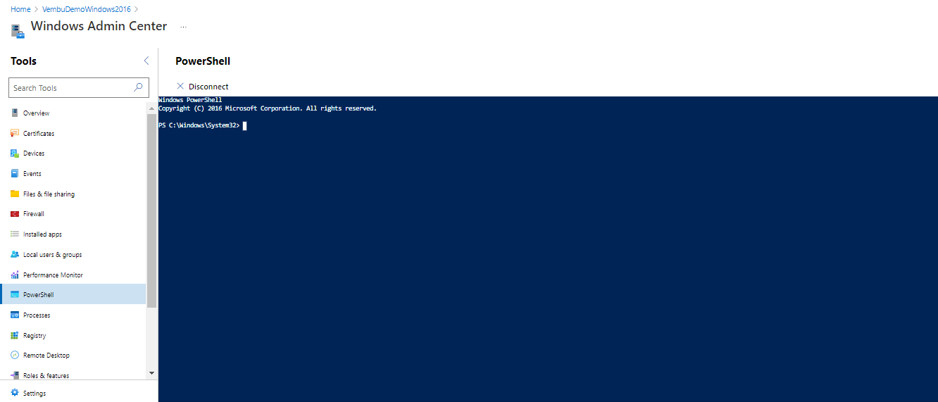

## Processes

Similar to task managers, you can view the running processes of the OS. You can start and end processes & find handles of each process.

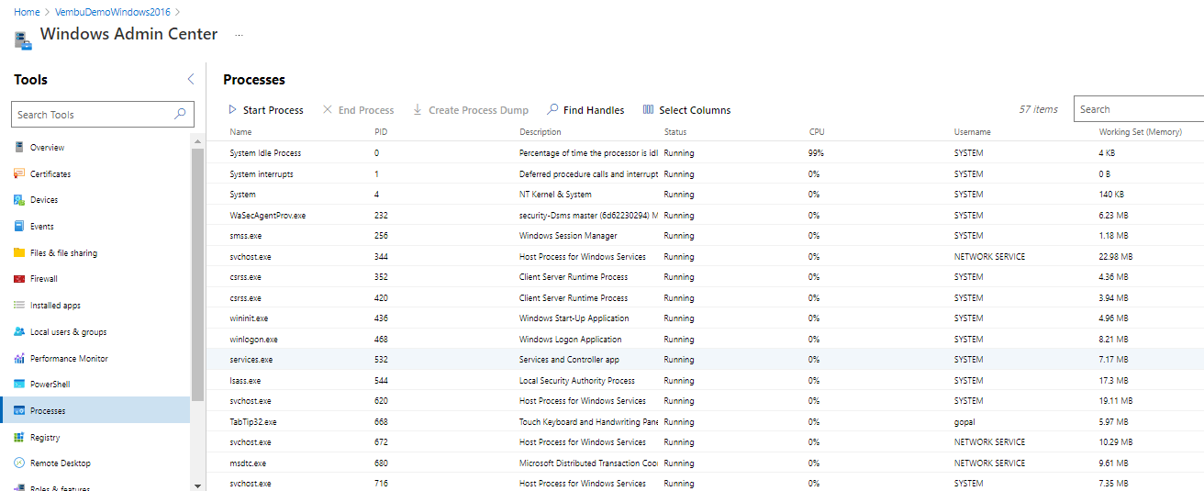

## Registry

Similar to the Regedit tool in windows, here you can traverse all the registry keys and can update the registry key value.

## Remote Desktop

Users can directly connect the server using RDP protocol after providing the admin user credentials.

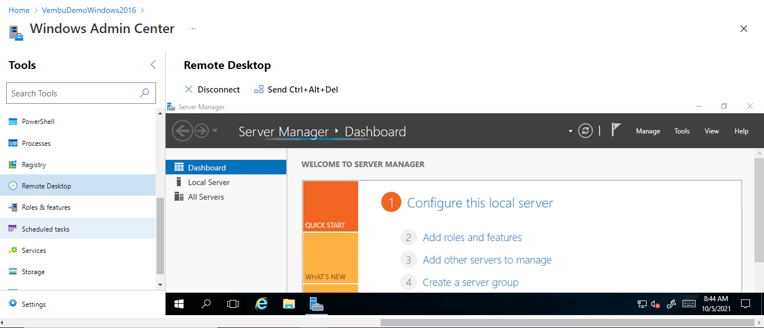

## Roles and features

Users can install & uninstall roles and features for the OS.

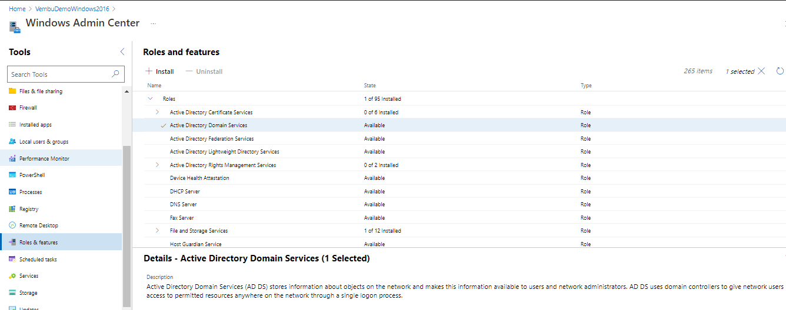

## Storage

Users can perform all the disk and storage operations. One can create volume, create, attach and detach VHD, can format and resize the disk volumes, etc.

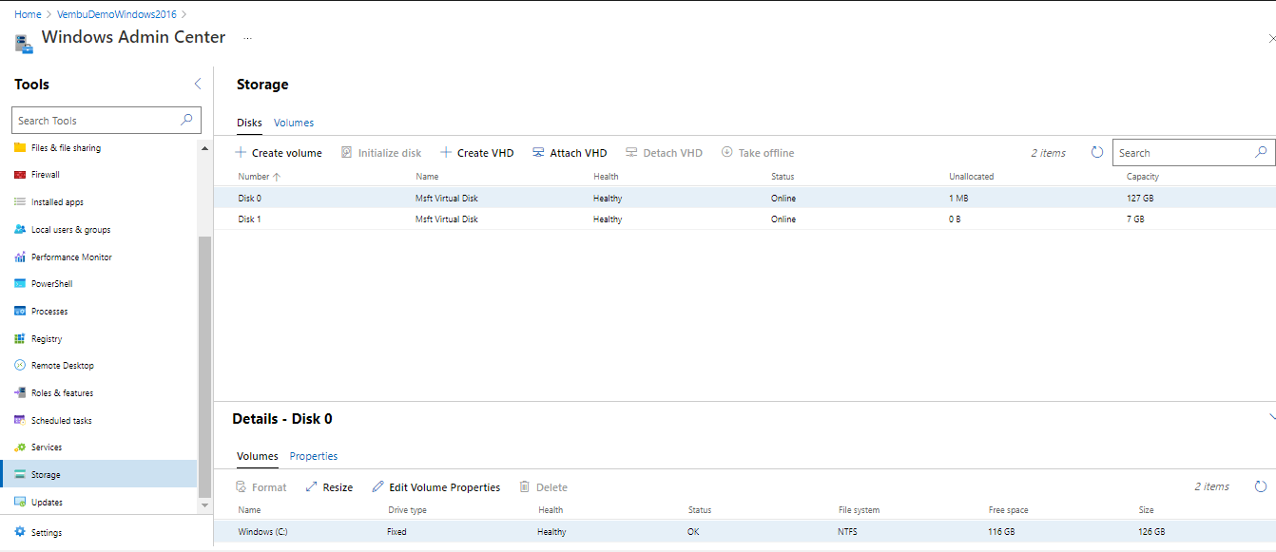

## Updates

Shows available updates and updated history. Users can initiate installing Windows security updates and patches from here.

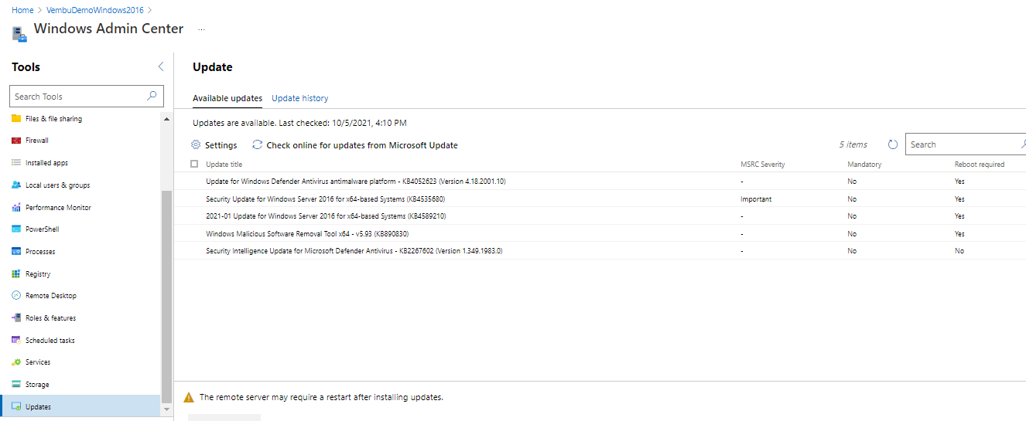

## Settings

Here users can configure file share SMB server, Environment variables, and Power configuration for the Windows OS.

# 

# Conclusion:

Windows Admin Center in Azure unlocks incredible capabilities for the Azure portal by providing the user with an interface to manage Windows Server virtual machines.

By default, the Azure portal provides a singular view for virtual machine management and the essential elements to manage the infrastructure. With the addition of Windows Admin Center in Azure, we have supplemented this great management experience with additional opportunities such as an enhanced view of virtual machine usage, performance monitoring, viewing of events, and much more.

Also, it is pretty much easy to install the Windows Admin Center extender package on Azure Windows VMs and can manage the resources instantly.